**.Department of Computer Science & Engineering.**

Report on Mini Project

GOURMET GRILLHOUSE  
WEBSITE FOR A RESTAURANT

#### Course Code : CS1102-1

#### Course Name : Front End Web Development

##### Semester: III SEM

##### Section: A

**Submitted To:**

## Mr. AkhilRaj Gadakar

## Department of Computer Science and Engineering

**Submitted By:**

Saif Sheikh (NNM22CS152)

Vijeth Achar (NNM22CS206)

#### 



## **CERTIFICATE**

This is to certify that the “MINI PROJECT” submitted by

Mr. **SAIF SHEIKH** bearing USN **NNM22CS152** and Mr. **VIJETH ACHAR** bearing USN **NNM22CS206** of third semester B.Tech., a student of NMAM Institute of Technology, Nitte, has undergone Mini Project on **GOURMET GRILLHOUSE- WEBSITE FOR A RESTAURANT** using HTML, CSS, PHP & JavaScript. It has been found Satisfactory, and hereby approved for submission.

Signature Of Faculty Signature Of HOD

**ABSTRACT**

The Gourmet Grillhouse Website project is an ambitious venture aimed at seamlessly translating the opulence of an upscale restaurant into the digital realm. This report delves into the comprehensive methodology, multifaceted implementation, and the rich array of features that constitute the Gourmet Grillhouse website. Developed using a combination of HTML, CSS, and JavaScript, the website not only showcases the culinary offerings but also provides an immersive online experience for patrons. The report navigates through the intricacies of requirements analysis, design, implementation, and discusses the outcomes and potential future enhancements.

# TABLE OF CONTENTS

Certificate 2

Abstract 3

Table of Contents 4

Introduction 5

Objectives 6

Template 7

Methodology 8

Implementation Details 9

Results 10

Conclusion and Future Scope 14

References………………………………………………………………………………………..…15

**INTRODUCTION**

Gourmet Grillhouse, an epitome of culinary excellence, embarks on a digital expedition with its sophisticated website. The introduction section sets the stage by elucidating the project's overarching vision: to seamlessly blend the restaurant's opulent brand identity with an enticing, user-friendly online interface. The integration of HTML, CSS, and JavaScript is highlighted as the driving force behind the creation of an all-encompassing virtual dining experience.Our passion for serving exceptional food and creating a warm, inviting atmosphere is at the heart of everything we do. At Gourmet Grillhouse, we believe in the power of taste to bring people together, and we strive to create memorable moments around the table.In the contemporary era, where online presence is integral for businesses, Gourmet Grillhouse recognizes the need for a dynamic website that not only mirrors the ambiance of its physical space but also offers a seamless interaction for patrons exploring the culinary offerings.

### Key Features:

1. Attractive Visual Design
2. Menu Display
3. Online Ordering  Reservation System
4. Contact Information
5. About Us
6. Customer Reviews and Testimonials
7. Events
8. Social Media Handles
9. Newsletter

**PROBLEM STATEMENT**

The transition from a physical dining space to an engaging online platform poses several challenges. This section delves into the intricacies of effectively conveying the restaurant's ambiance, presenting a tantalizing menu, and ensuring an intuitive user experience. The challenge lies in encapsulating the essence of Gourmet Grillhouse's fine dining experience within the digital realm, balancing aesthetics with functionality.

Maintaining consistency in visual representation, fostering user engagement, and ensuring that the online platform mirrors the luxury associated with the physical establishment are key obstacles that need to be overcome.

.

**OBJECTIVES**

A meticulous breakdown of the project's objectives underscores the commitment to crafting an intuitive, visually appealing interface. Objectives include:

1. **Showcasing Culinary Offerings:** Present the restaurant's menu in an enticing and easily navigable manner.
2. **Generating Interest:** Create visually captivating elements to capture users' attention and evoke curiosity.
3. **Facilitating Reservations:** Implement a reservation system to streamline the booking process for patrons.
4. **Communication Channels:** Provide seamless communication channels, including contact forms, to enhance user interaction.

The multifaceted nature of these objectives reflects the comprehensive approach adopted for the website's development.

**METHODOLOGY**

A systematic methodology is outlined, commencing with a thorough analysis of requirements and user expectations. The design phase is explored in detail, focusing on creating an interface that harmonizes with the restaurant's brand identity. The implementation phase utilizes HTML, CSS, and JavaScript, with a keen eye on responsive design principles. Continuous testing and iterative refinement underscore the commitment to delivering a flawless user experience.

**Requirements Analysis:** Identify the key functionalities required for an upscale restaurant website.

**Design Phase:** Collaborate on the creation of wireframes and visual mockups to define the website's look and feel.

**Implementation:** Leverage HTML for structural elements, CSS for styling, and JavaScript for interactivity.

**Testing:** Conduct iterative testing to identify and address any issues related to usability, responsiveness, and functionality

**IMPLEMENTATION**

This section provides an in-depth exploration of the website's architecture and functionality. Multiple HTML files cater to different pages, including:

* **Home:** Introduce users to the ambiance and offerings of Gourmet Grillhouse.
* **About:** Provide insights into the restaurant's history, philosophy, and culinary expertise.
* **Contact:** Offer seamless communication channels for inquiries and feedback.
* **Reservations:** Streamline the booking process for patrons.
* **Events:** Showcase upcoming events, enhancing user engagement.
* **VIP Dining:** Highlight exclusive VIP dining experiences.

The symbiotic relationship between CSS stylesheets and HTML elements is examined, elucidating how visual appeal is achieved. The role of JavaScript in enhancing user interaction and responsiveness is emphasized. The website's structure is dissected to underscore its adaptability across various devices.

**RESULTS AND DISCUSSIONS**

Tangible outcomes of the Gourmet Grillhouse website are dissected, with a keen focus on the visual allure and interactive elements. The image slider, meticulously designed event sections, and detailed VIP dining features are discussed.

* **Image Slider:** The inclusion of an image slider showcases the restaurant's ambiance, offering users a virtual tour.
* **Event Sections:** Meticulously designed event sections provide a platform for showcasing upcoming events, fostering user engagement.
* **VIP Dining Features:** Detailed VIP dining features underline the exclusivity of the dining experience, enticing patrons to elevate their culinary journey.

User feedback and iterative testing are highlighted as integral components in achieving a refined, user-centric platform.

1. **HOME PAGE:**

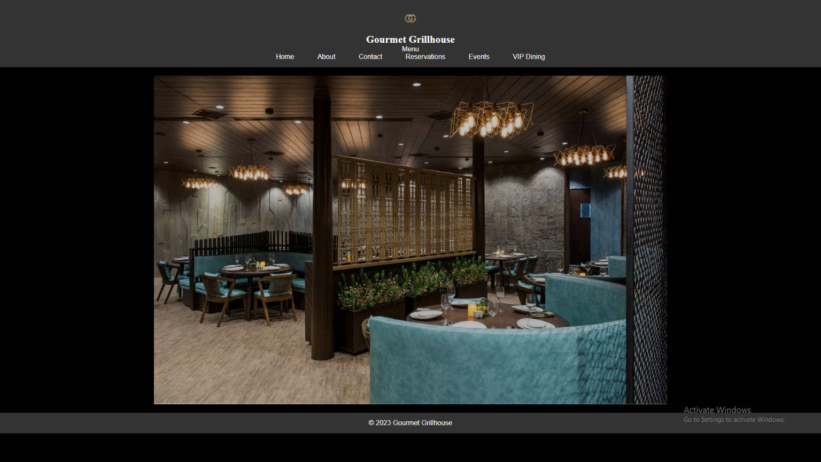

**2.ABOUT PAGE:**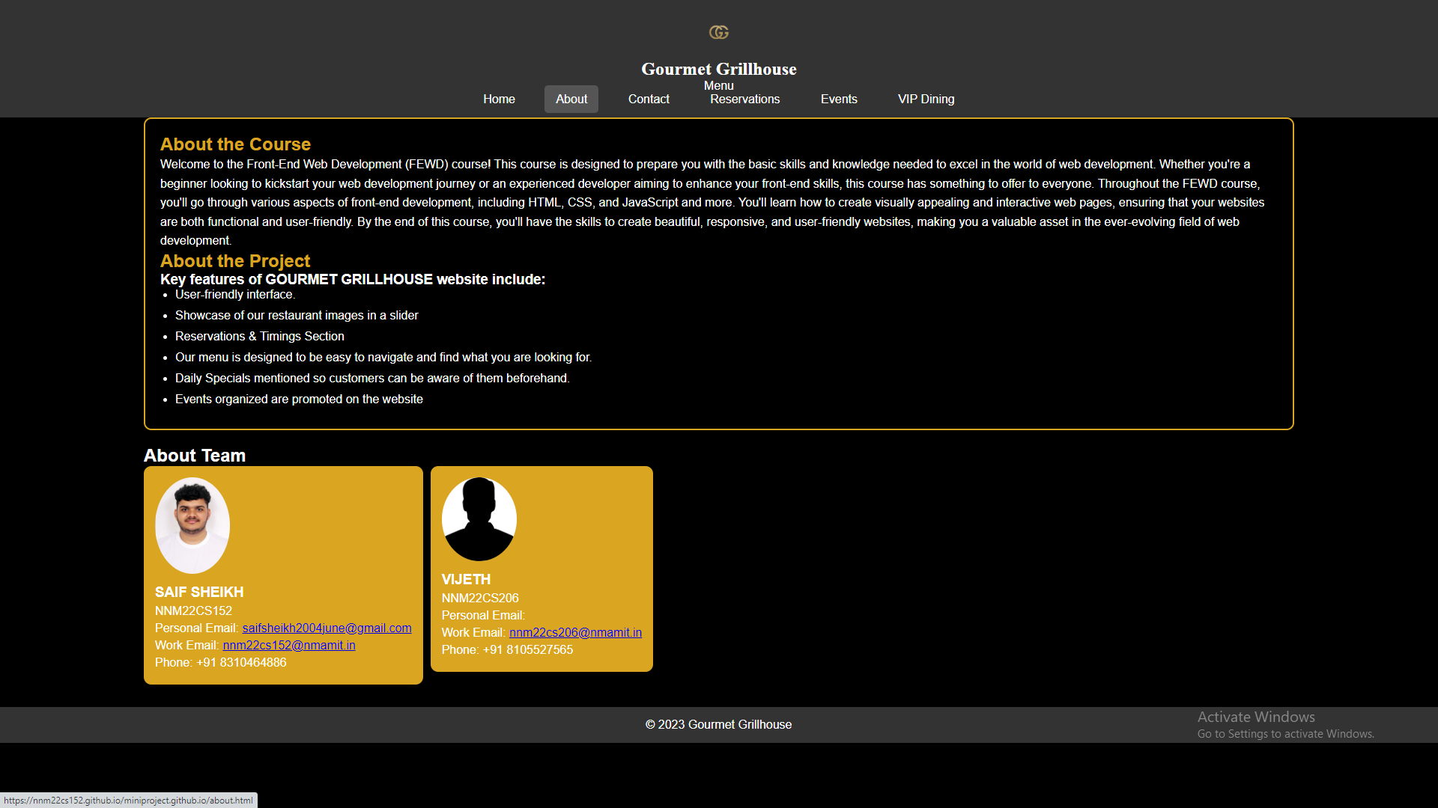

**3.CONTACT PAGE:**

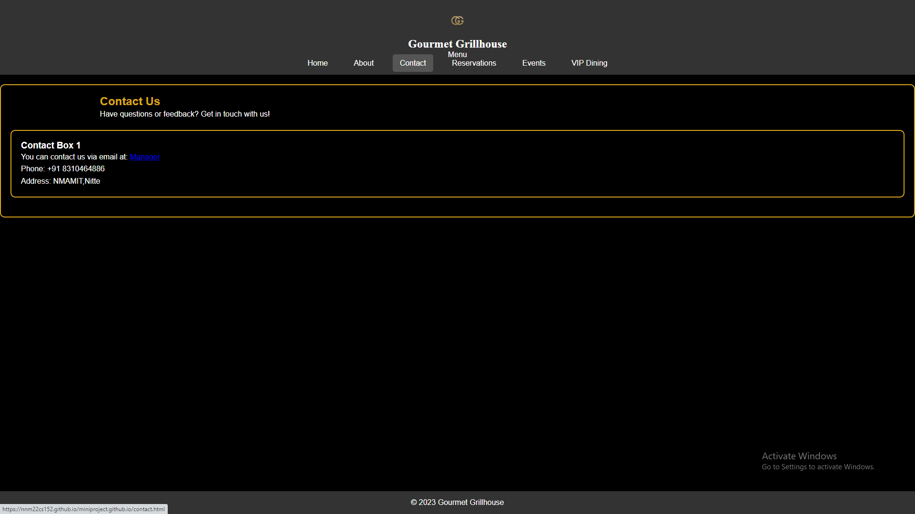

**4.RESERVATION PAGE:**

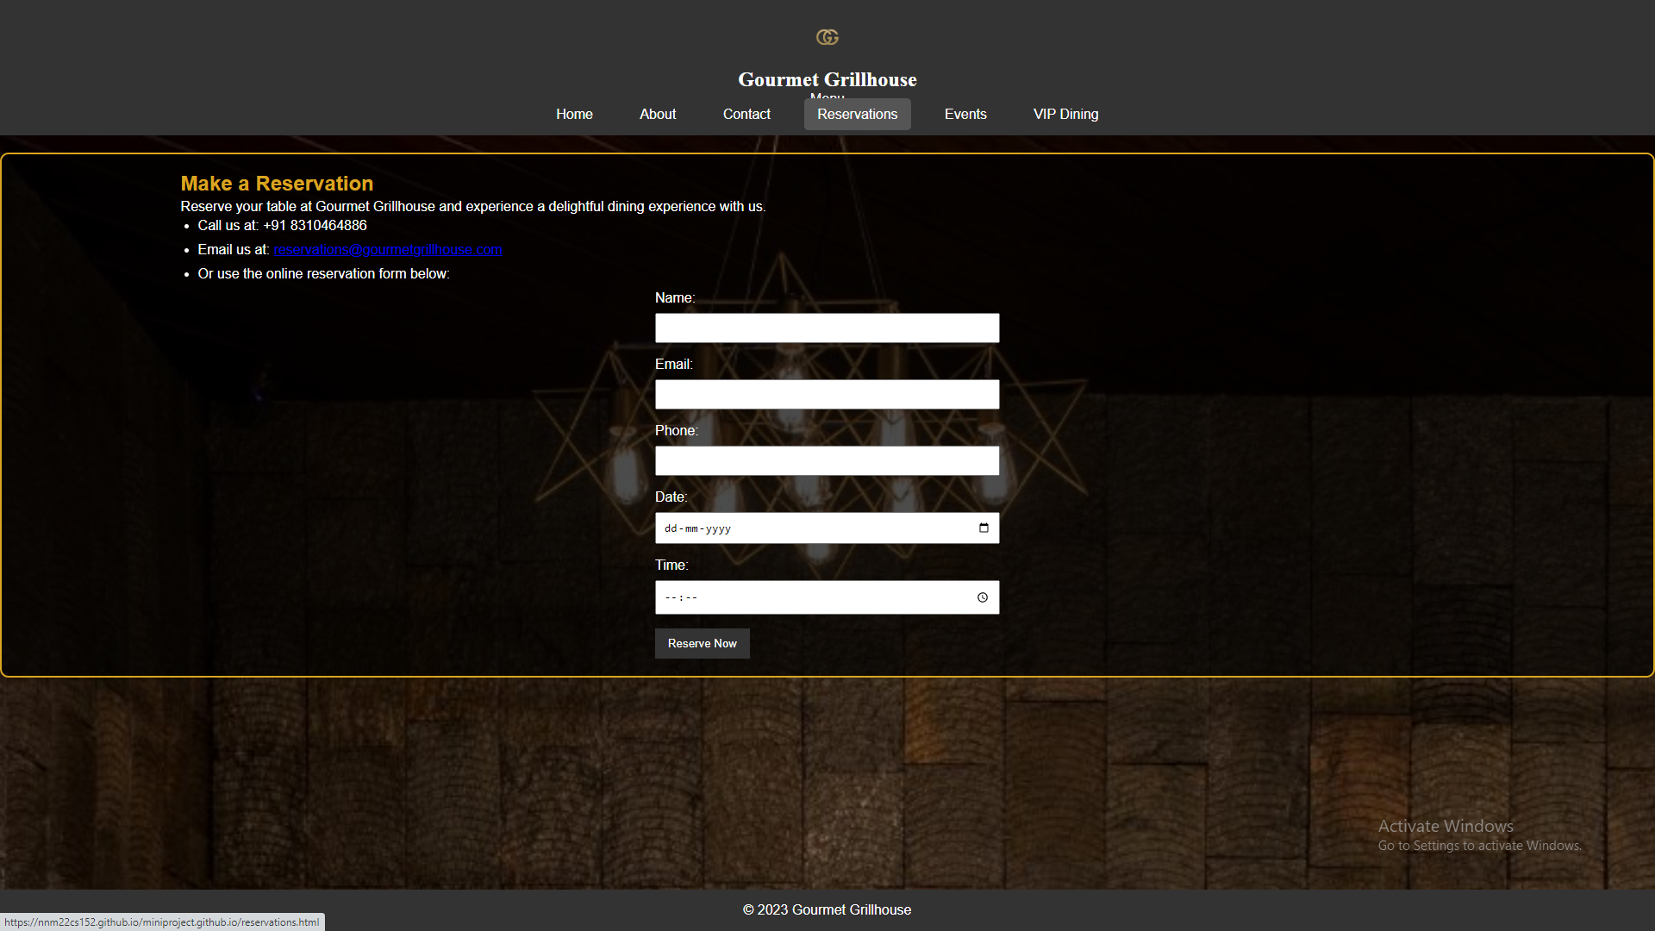

**5.EVENTS PAGE:**

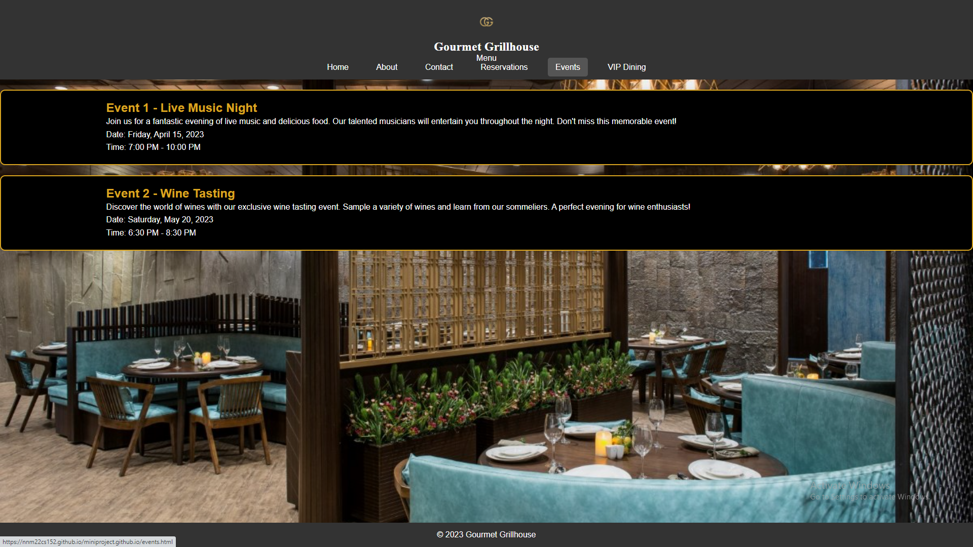

**6.VIP DINING PAGE:**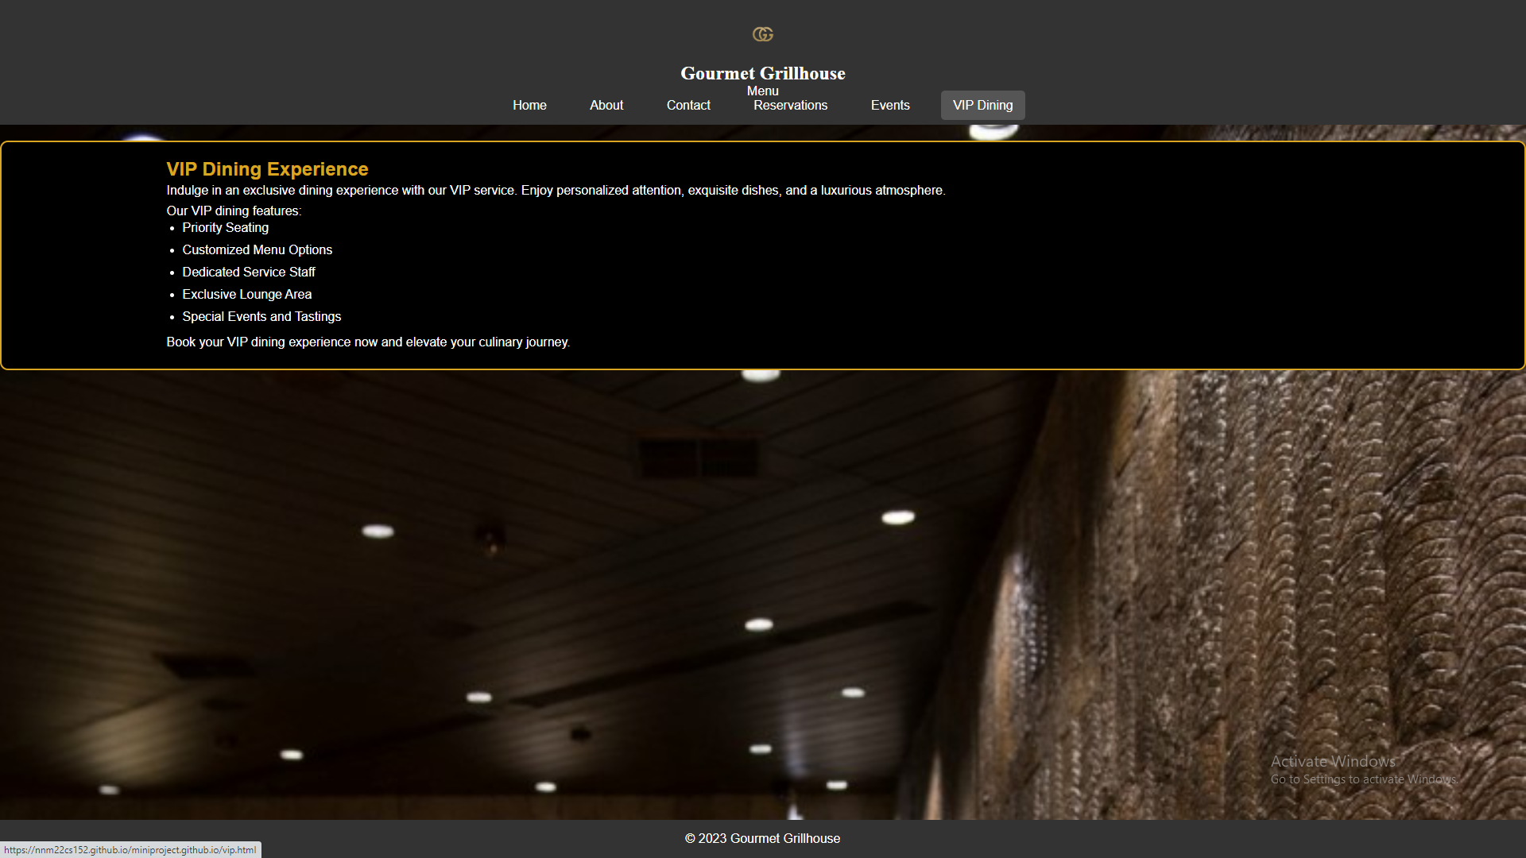

**CONCLUSION AND FUTURE ENHANCEMENTS**

The conclusion encapsulates the success of the Gourmet Grillhouse Website project in achieving its objectives. Future enhancements are proposed, including:

* **Online Reservations:** Implement an online reservation system for user convenience.
* **Social Media Integration:** Integrate social media platforms to foster community engagement.
* **Customer Reviews:** Include a section for customer reviews, adding a layer of authenticity to the user experience.
* **Continuous Iteration:** The modular structure of the website is celebrated for its scalability and adaptability to evolving trends, ensuring continuous growth and adaptation.

**REFERENCES**

* W3Schools (<https://www.w3schools.com/>)
* Google Fonts (<https://fonts.google.com/>)
* <https://thearchitectsdiary.com/vintage-looking-restaurant-design-has-modern-experience-neovana-design/> - for royalty-free images
* Coding Nepal (<https://www.codingnepalweb.com/>)
* Web Development Tutorial on YouTube <https://www.youtube.com/watch?v=HqMHqBY5C4U>

Top of Form